IDENTIFY NEW BIKES PROJECT

Software Requirements Specification

|  |  |  |  |
| --- | --- | --- | --- |
|  | Prepared By | Reviewed By | Approved By |
| Name | AutoMates | Devathilagai |  |
| Role | Interns | Batch Trainer |  |

**Table of Contents**

Table of Contents…………………………………………………………...….......II

1. Introduction…………………………………………………………………...…1

1.1 Intended Audience……………………………………………….......1

1.2 Project Scope…………………………...……………………………1

2. Overall Description…………………………………………….……………….1

2.1 Operating Environment……………………...……………………....1

3. Requirements……………………………………………………………...…….1

3.1 Login………………………………………………………………….2

3.1.1Description………………………………………………....2

3.1.2 Functional Requirements ….………...…………………...2

**1. Introduction**

This document outlines the automation strategy and requirements for the Identify Car Wash Services project. The project automates ten distinct workflows across various service categories using Selenium WebDriver with Java, TestNG, Apache POI, Cucumber, and other supporting frameworks. The goal is to ensure robust, scalable, and maintainable automation for UI and data-driven testing.

**1.1 Intended Audience**

Business Unit (BU) SME

Academy coach

Technical Trainer

**1.2 Project Scope**

This document outlines, at a functional level, the service discovery and filtering operations supported by the JustDial platform and the key rules governing them. It also incorporates both high-level and detailed technical requirements relevant to the automation process.

The scope leverages insights from the proposed test frameworks, structured feature files, and modular page object architecture. As part of the detailed analysis phase, this document will include:

* Classification of automation requirements grouped by workflow type and service category (e.g., car wash, hostel, restaurant)
* A breakdown of each automated process, specifying inputs (Excel/JSON data, filters, search terms), expected outputs (top listings, error messages), and the steps involved in UI interaction and data validation
* Validation guidelines for extracted information, form submissions, filtering logic, and error handling across different sections of the platform

**2. Overall Description**

**2.1 Operating Environment**

**OS:** Windows

**Type:** Web Application (JustDial)

**Browser Support:** Chrome, Edge

**Project Management Tool:** Jira

**Testing Tools:** Selenium, TestNG, Apache POI, Junit, BDD Cucumber, Allure, Log4j

**3. Requirements**

This part of the requirements document serves to present the "JustDial for identifying various services" of the application, we need to extracts and validates key details such as service names, ratings, and contact information, while excluding OTP-based login flows due to technical limitations.

**3.1.1 Functional Requirements**

**3.1.1.1 Req0001**

* **Req0001a-** The user sets the location using data from the Excel sheet (via Apache POI).
* **Req0001b**-The user enters a search term i.e., “Car Wash Service” and initiates the search.
* **Req0001c-**The system displays a list of car wash services relevant to the location and search term..
* **Req0001d-** The user applies a filter from excel to show only services with the more than 20 votes.
* **Req0001e** – The user then captures the top five results.
* **Req0001f** – The system validates that exactly five entries are displayed and that the search results contain the keyword "car wash".

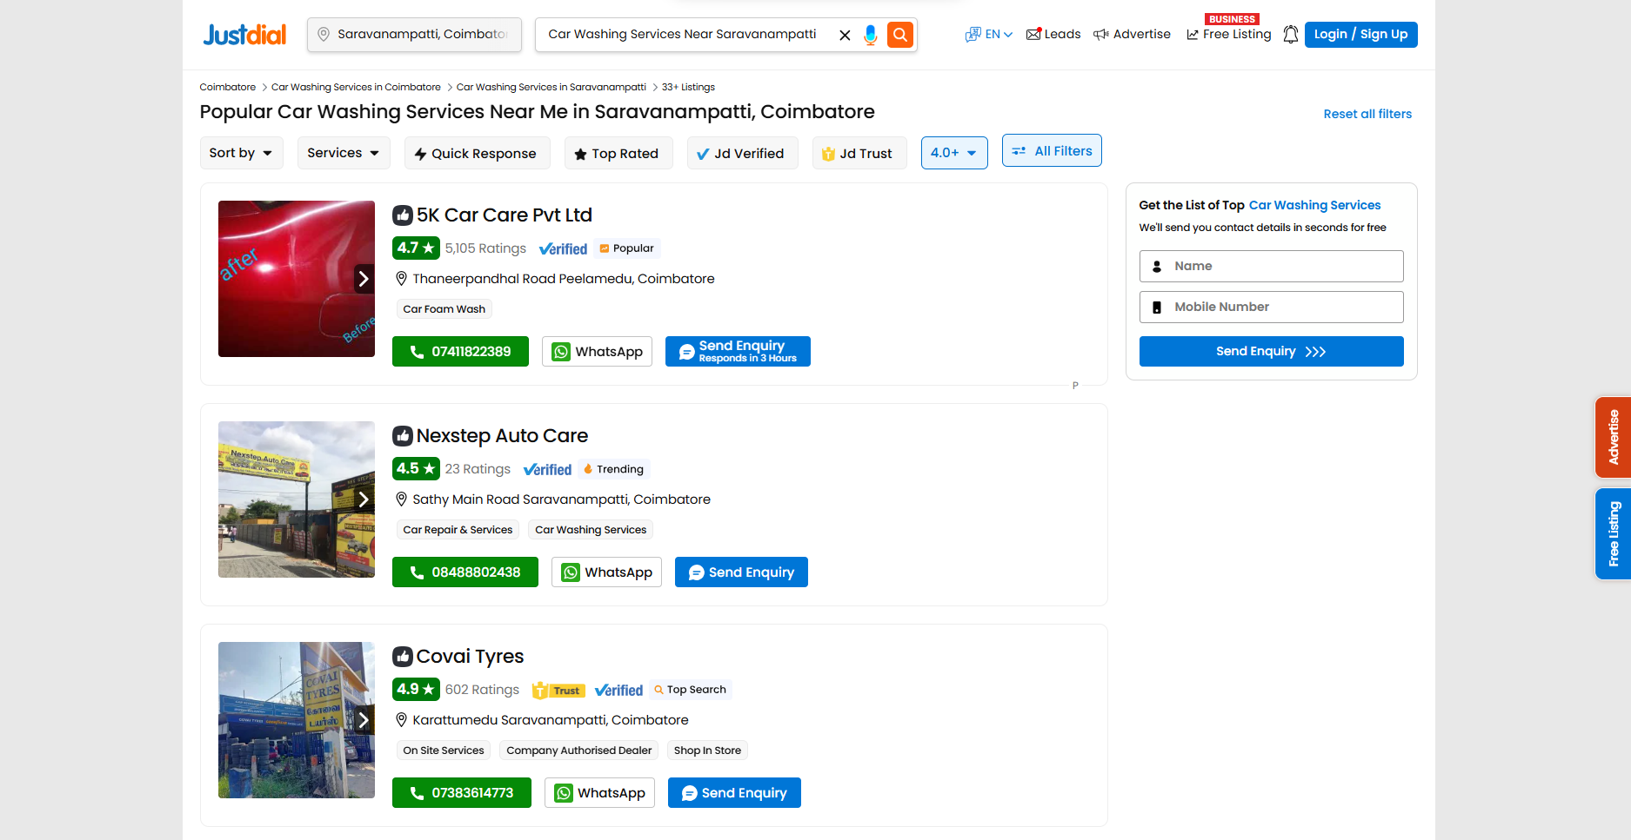

**3.1.1.2 Req0002**

* **Req0002a –** The user navigates to the Free Listing page from the homepage.
* **Req0002b –** The user enters an invalid phone number retrieved from the Excel sheet.
* **Req0002c –** The user submits the form with the invalid phone number.
* **Req0002d –** The system displays an error message indicating the phone number is invalid.
* **Req0002e –** The automation captures and displays the error message for verification.
* **Req0002f –** The system validates that the error message matches the expected format or content.

**3.1.2.3 Req0003**

* **Req0003a –** The user scrolls down to the “Popular Categories” section on the homepage.
* **Req0003b –** The user selects the category from the Excel sheet**.**
* **Req0003c –** The system displays subtypes related to Gym and Fitness under the selected category.
* **Req0003d –** The automation captures and displays the discovered submenu options for verification.

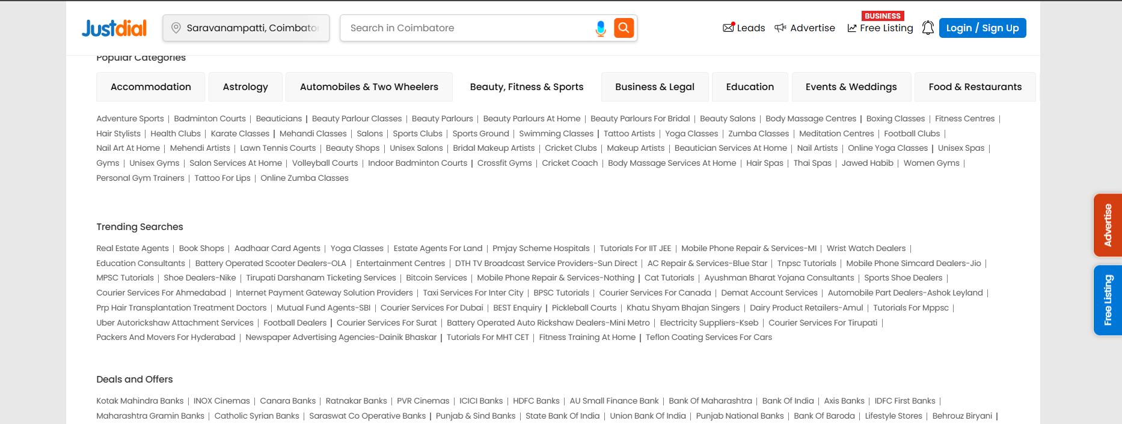

**3.1.2.4 Req0004**

* **Req0004a** – The user initiates a search for “Hostels” using location data from the Excel sheet.
* **Req0004b** – The system displays a list of available hostels based on the search criteria.
* **Req0004c** – The user applies filters to show only hostels that are top-rated, and JD Verified.
* **Req0004d** – The automation captures and displays the top five hostels along with their names and locations.
* **Req0004e** – The system verifies that each displayed hostel is in Coimbatore and asserts the result for accuracy.

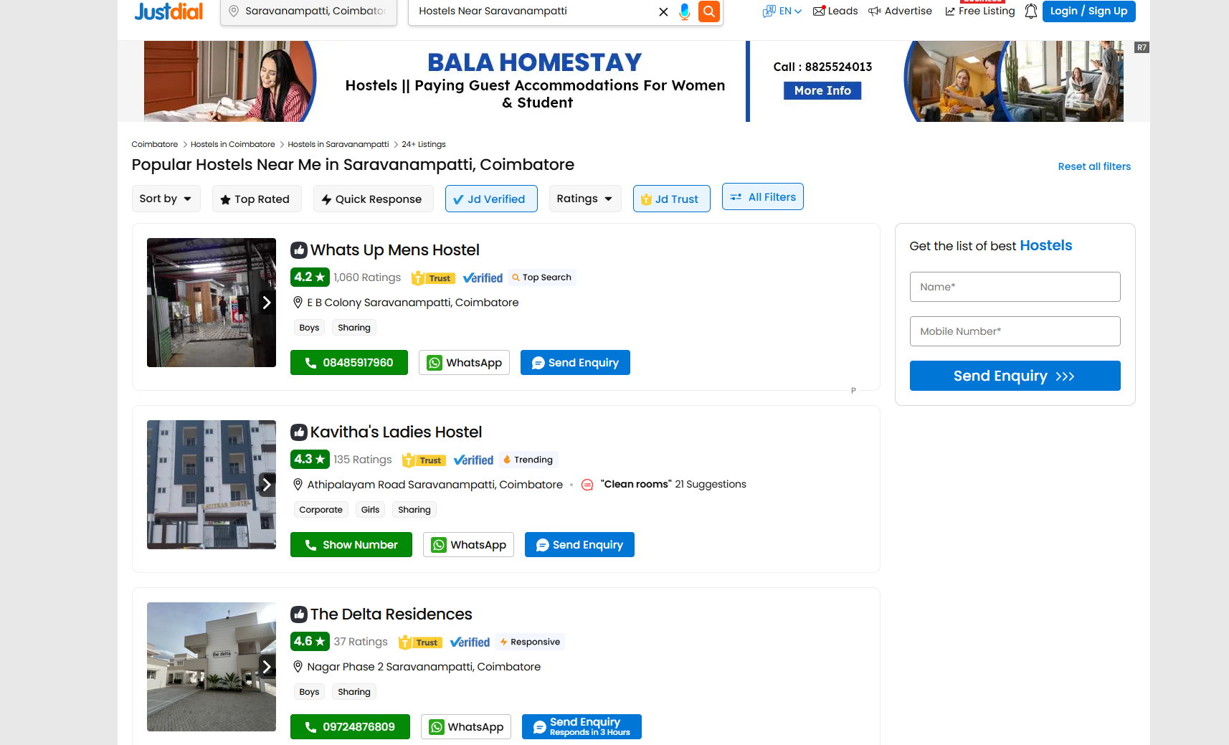

**3.1.2.5 Req0005**

* **Req0005a** – The user initiates a search for "Restaurants" near the location from the Excel sheet.
* **Req0005b** – The system displays a list of restaurants relevant to the location.
* **Req0005c** – The user applies filters to show only restaurants that are currently open.
* **Req0005d** – The user further filters the list to include only those offering South Indian cuisine and online delivery.
* **Req0005e** – The automation captures and displays the top five restaurants along with their names, ratings, and number of votes.
* **Req0005f** – The system validates that the displayed results meet all filter criteria and are limited to five entries.

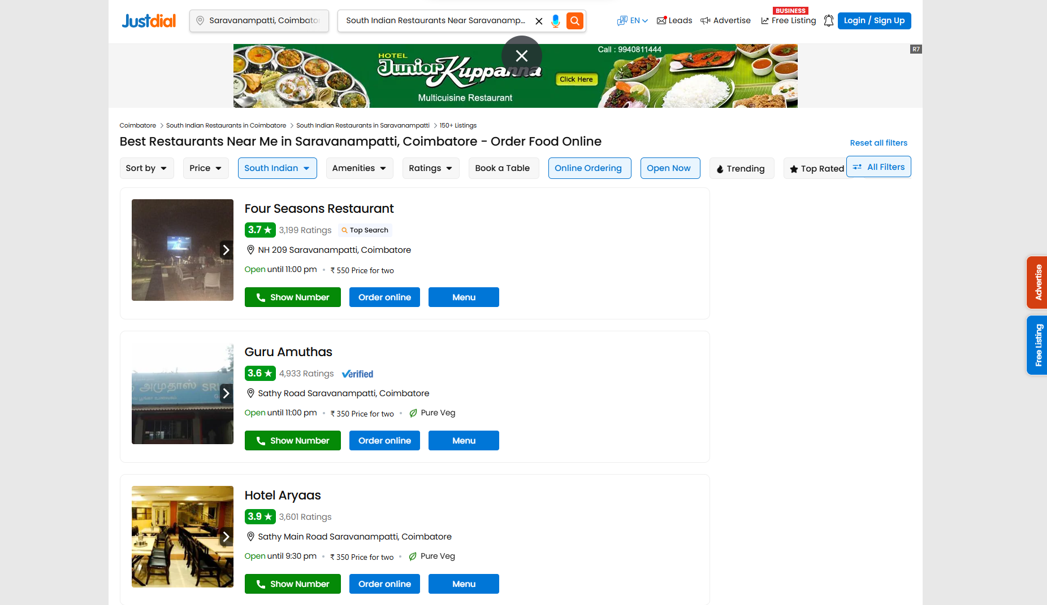

**3.1.2.6** **Req0006**

* **Req0006a –** The user clicks on the “Popular Categories” section on the homepage.
* **Req0006b –** The system reads a list of search terms from a JSON file .
* **Req0006c –** The user performs a search for each term in the list sequentially.
* **Req0006d –** The system displays matching categories for each search term.
* **Req0006e –** The automation captures and displays the search results for validation.

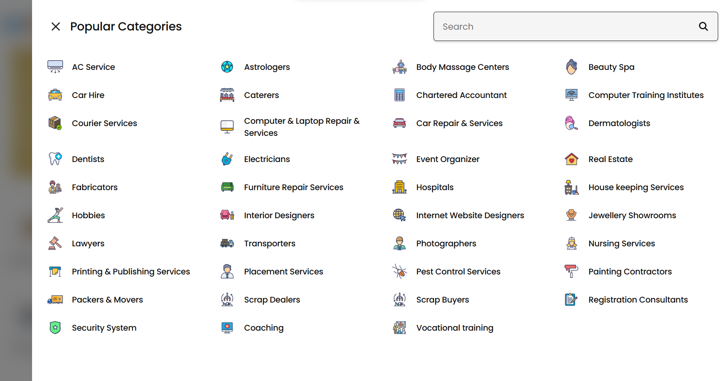

**3.1.2.7 Req0007**

* **Req0007a** – The user scrolls down to the tourist location specified by the Excel sheet.
* **Req0007b** – The user selects the first option from the displayed tourist spots.
* **Req0007c** – The system navigates to the location-specific page.
* **Req0007d** – The automation captures the top five results in each of the following categories: Hotels, Restaurants, Coffee Shops, Travel Agents, and Visiting Spots.
* **Req0007e** – The system validates that the captured results are correctly categorized and displayed.

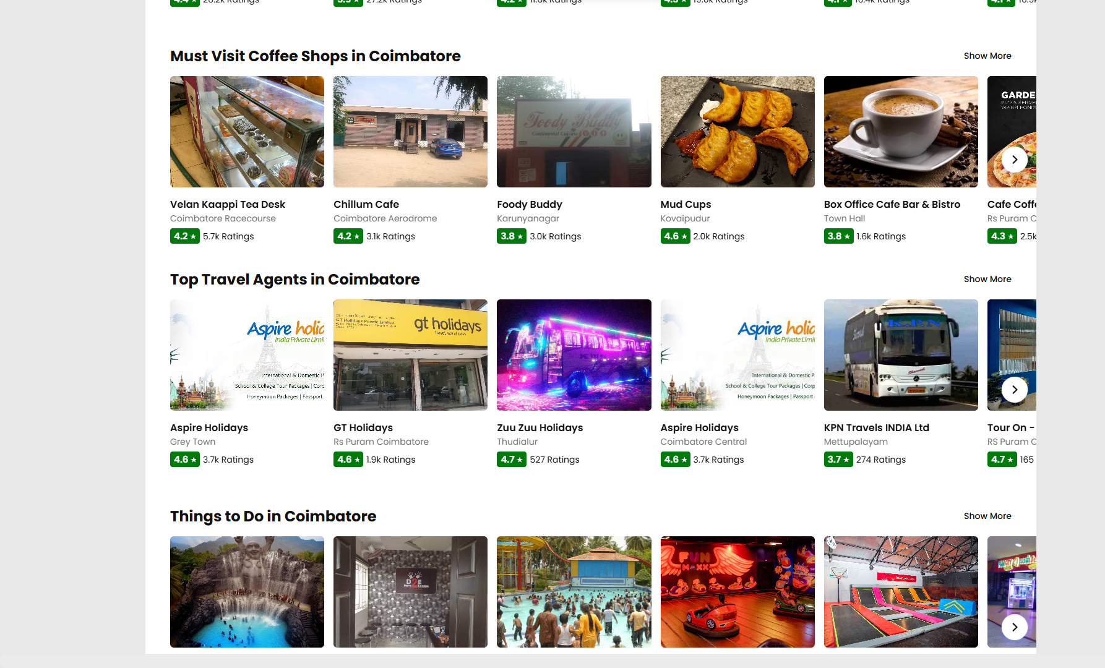

**3.1.2.8 Req0008**

* **Req0008a –** The user launches the travel platform homepage**.**
* **Req0008b**– The user selects the “Bus” booking category**.**
* **Req0008c –** The user enters “Coimbatore” as the origin and “Chennai” as the destination.
* **Req0008d –** The user selects a journey date and initiates the bus search.
* **Req0008e –** The user enables the filters “Non-AC” and “Sleeper” to refine the results.
* **Req0008f –** The automation extracts and displays the top five buses with operator name, departure time, and fare using filters from Excel.
* **Req0008g –** The system validates that both filter checkboxes are functional using the same Excel**.**
* **Req0008h –** The automation stores the result (Pass or Fail) in the Excel sheet for reporting.

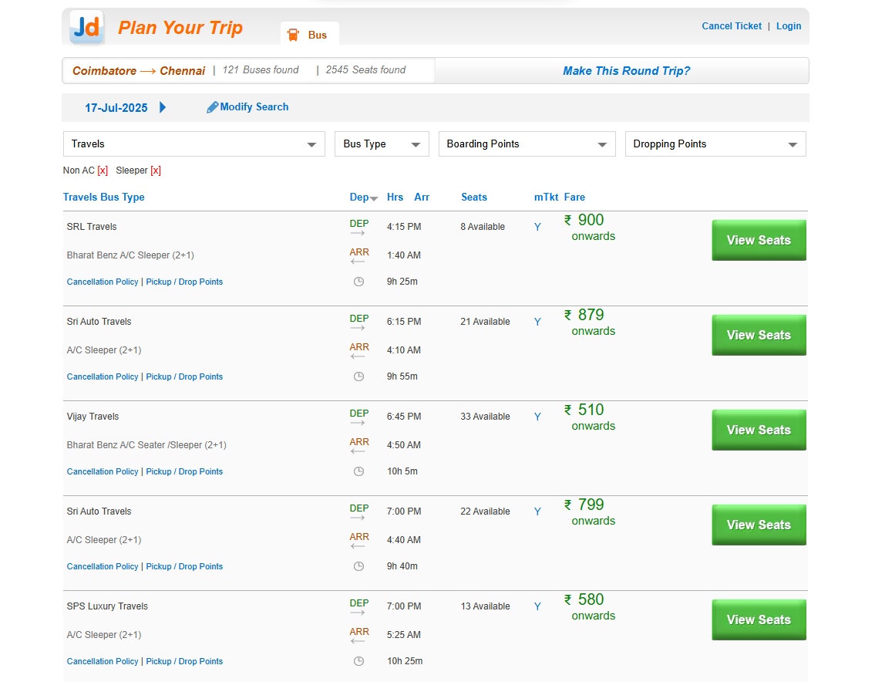

**3.1.2.9 Req0009**

* **Req0009a –** The user scrolls down to the “Latest Movies & Reviews” section on the homepage.
* **Req0009b –** The user clicks on the “More Options” button to navigate to the Movies page.
* **Req0009c –** The user applies filters for Language, Format, and Genre using data from Excel.
* **Req0009d –** The system displays a list of theaters showing the filtered movie.
* **Req0009e –** The automation captures the top six theater names along with their respective show timings.

**3.1.2.10 Req0010**

* **Req0010a –** The user scrolls down to the “Mobile Recharge Options” section on the homepage.
* **Req0010b –** The user clicks on the “Type” service menu to access recharge categories.
* **Req0010c –** The system navigates to the Mobile Recharge page.
* **Req0010d –** The user enters a valid mobile number retrieved from the XML input.
* **Req0010e –** The user applies the “Plan” filter to view relevant data plans.
* **Req0010f –** The system displays the available recharge plans.
* **Req0010g –** The automation captures and displays the top five mobile data plans for validation.

